Project Design Phase-II
Data Flow Diagram & User Stories

Date | 14/7/2026
Team ID | SWTID-2026-1032
Project Name | EduGenie – Google Gemini Powered Learning Assistant
Maximum Marks

Data Flow Diagram (DFD)
A Data Flow Diagram (DFD) is a graphical representation of how information flows through a system. It illustrates how user input is processed, how data moves between different components, and how the final output is generated. In the EduGenie Learning Assistant, the DFD helps visualize the interaction between the user, frontend, backend, AI models, and database.
DFD Level 0 (Context Diagram)
External Entity
- User (Student, Self-Learner, Educator)
Main Process
- EduGenie Learning Assistant
Data Flow
- User enters an educational query.
- EduGenie processes the request.
- Depending on the selected feature, the request is sent to the appropriate AI module.
- Gemini 1.5 Pro or LaMini-Flan-T5 generates the response.
- The response is stored in the database.
- The generated result is displayed to the user.
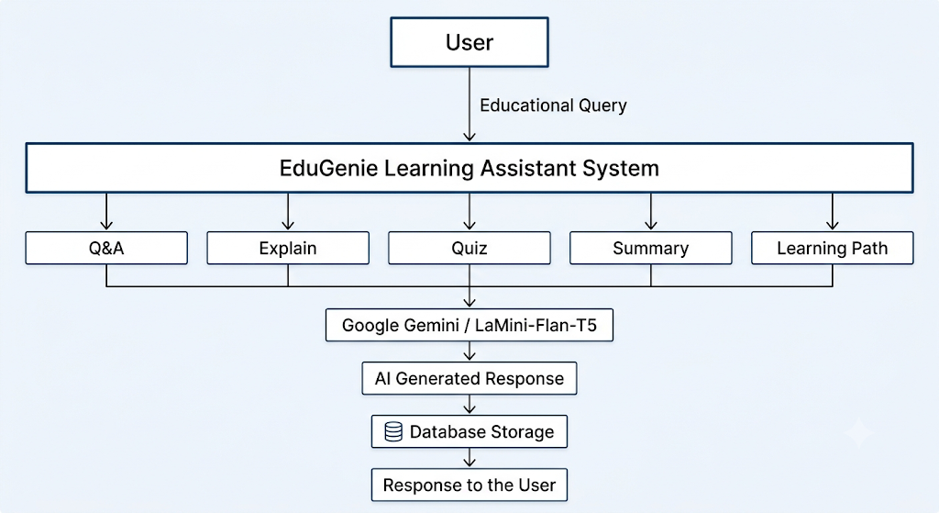
DFD Level 1
The EduGenie Learning Assistant consists of five major processing modules.
Process 1: Question Answering
- User submits a question.
- FastAPI receives the request.
- Gemini 1.5 Pro generates an answer.
- The answer is stored in the AI_RESPONSE table.
- The response is displayed.

Process 2: Concept Explanation
- User enters a topic.
- LaMini-Flan-T5 generates a simplified explanation.
- Explanation is returned to the frontend.

Process 3: Quiz Generation
- User selects Generate Quiz.
- Gemini generates multiple-choice questions.
- Quiz is stored in the QUIZ table.
- Questions are displayed.

Process 4: Text Summarization
- User enters lengthy text.
- Gemini summarizes the content.
- Summary is stored in the SUMMARY table.
- Short summary is displayed.

Process 5: Learning Recommendation
- User enters a learning topic.
- Gemini generates a structured learning roadmap.
- Recommendations are stored in the LEARNING_PATH table.
- Learning path is displayed.
User Type | Functional Requirement (Epic) | User Story Number | User Story / Task | Acceptance Criteria | Priority | Release
Student / Learner | Registration | USN-1 | As a user, I can register with my name, email, and password to access EduGenie. | User account is created successfully. | High | Sprint-1
Student / Learner | Login | USN-2 | As a user, I can log in securely using my registered credentials. | User is redirected to the dashboard after successful login. | High | Sprint-1
Student / Learner | Question Answering | USN-3 | As a user, I can ask academic questions and receive AI-generated answers. | Accurate educational response is displayed. | High | Sprint-1
Student / Learner | Concept Explanation | USN-4 | As a user, I can request simplified explanations for difficult topics. | Beginner-friendly explanation is generated. | High | Sprint-1
Student / Learner | Quiz Generation | USN-5 | As a user, I can generate multiple-choice quizzes on any topic. | Three or more MCQs with correct answers are displayed. | High | Sprint-2
Student / Learner | Text Summarization | USN-6 | As a user, I can summarize lengthy educational content. | Concise summary is generated successfully. | High | Sprint-2
Student / Learner | Learning Recommendations | USN-7 | As a user, I can receive a personalized learning roadmap. | Beginner, intermediate, and advanced learning path is generated. | High | Sprint-2
Student / Learner | AI Response History | USN-8 | As a user, I can view previously generated AI responses. | Stored responses are available for review. | Medium | Sprint-3
Administrator | User Management | USN-9 | As an administrator, I can monitor registered users and system usage. | User information can be accessed securely. | Medium | Sprint-3
Administrator | System Monitoring | USN-10 | As an administrator, I can verify that AI modules and APIs are functioning correctly. | System operates without errors and logs requests successfully. | Medium | Sprint-3

Functional Flow
- The user opens the EduGenie web application.
- The user logs in or accesses the learning interface.
- The user selects one of the available features:
  - Question Answering
  - Concept Explanation
  - Quiz Generation
  - Text Summarization
  - Learning Recommendations
- The frontend sends the request to the appropriate FastAPI endpoint.
- The backend validates the input and invokes the corresponding AI model.
- Google Gemini 1.5 Pro or LaMini-Flan-T5 generates the educational response.
- The generated output is stored in the respective database table.
- The response is returned to the frontend and displayed to the user in real time.

Conclusion
The Data Flow Diagram demonstrates how data moves through the EduGenie Learning Assistant, from user input to AI processing and response generation. The User Stories define the key functional requirements from the learner's perspective, ensuring that every major feature—Question Answering, Concept Explanation, Quiz Generation, Text Summarization, and Personalized Learning Recommendations—is implemented to meet user needs. This structured design provides a scalable, maintainable, and user-centric foundation for the EduGenie application.

